### **Assignment 5 Image Manipulation in a "Magic Lens"**

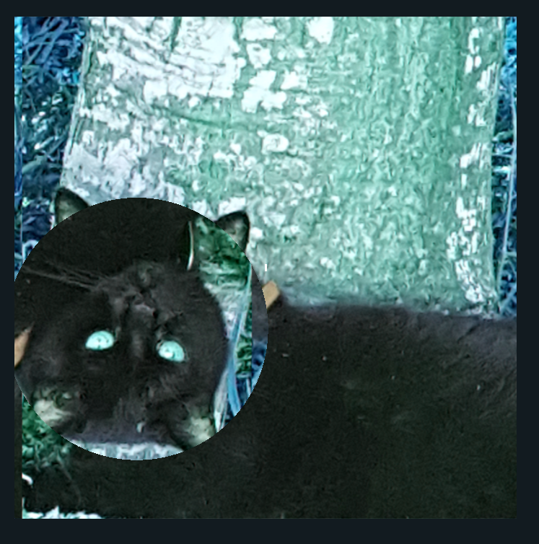

Video Link:

<https://media.oregonstate.edu/media/t/0_81lknbur>

Thank you very much, and have a good day!